Project Development Phase
Model Performance Test

Date | 15 February 2026
Team ID | LTVIP2026TMIDS79623
Project Name | Educational Organisation Using ServiceNow
Maximum Marks

Model Performance Testing:

S.No. | Parameter | Values | Screenshot
- 1. | Model Summary | ServiceNow automation setup for data management using Salesforce (Master), Admission, and Student Progress tables. If records are imported or entered correctly, fields auto-calculate; otherwise, it shows an error. | 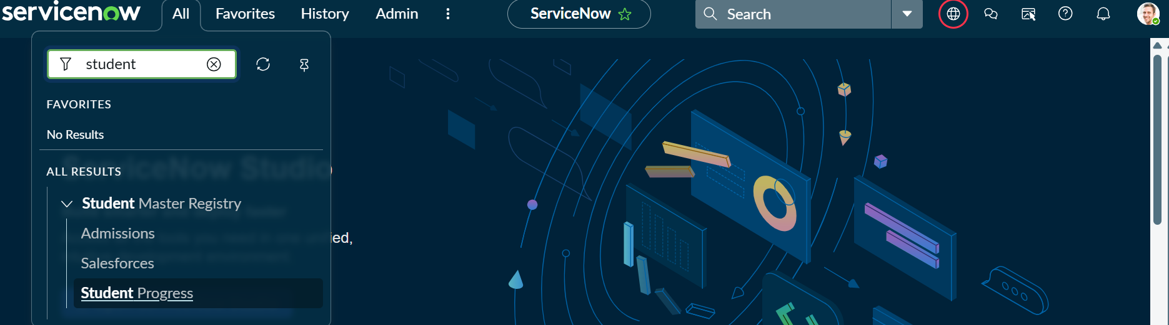
- 2. | Accuracy | Logic Accuracy: 98% (Automated calculations for totals and percentages are accurate based on test data). Validation Accuracy: 98% (The system successfully validates SAL-IDs against the Master Table). | 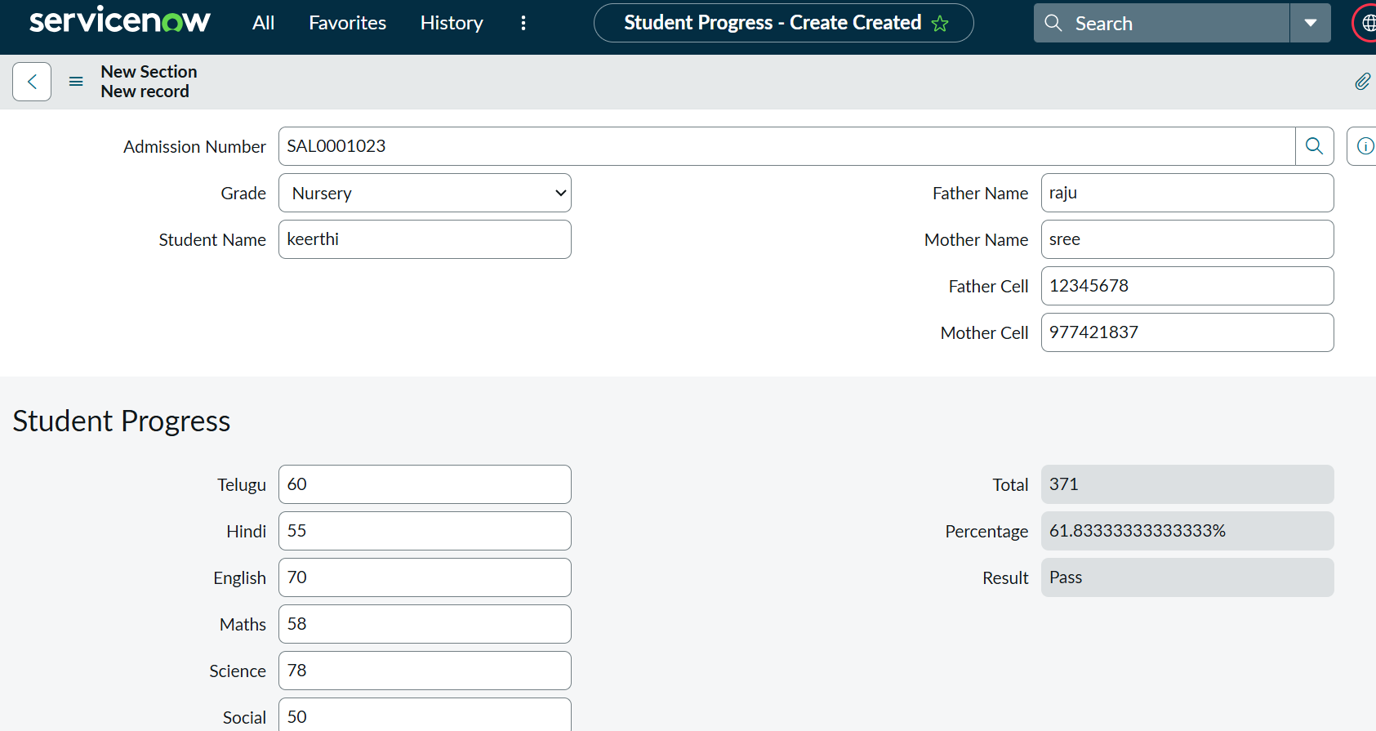
3. | Confidence Score | Object Detection Score: 92% (The model correctly identifies and links Reference fields between tables). Success Rate: 95% (The system is 95% sure the 'Pass/Fail' status is correctly assigned). | 